

VPN using Ubuntu

Computer Systems Technology

Submitted by:

*Adam Burke*

*Dean Devereaux*

Student number:

*R00128020*

*R00116198*

Supervisor &

Assessor:

*Pat Cogan*

Department of Electrical & Electronic Engineering

# Table of Contents

1. **Table of Contents**
2. **List of Figures**
3. **List of Tables**
4. **Abstract**
5. **VPN**
   1. **How VPN works**
6. **Results**
   1. **IP Location**
   2. **Speed Test**
7. **Conclusion**
8. **References**
9. **Appendices**

# Abstract

This report will consist of the research of a VPN and the procedures in which were completed to get a successful virtual private network. We will talk about the knowledge we learnt about VPN’s through class notes and study online, how a VPN works, OpenVPN the software application that was installed and configured, what complications were faced when setting up a connection, how it was verified that we successfully connected to a private network, speed test results of the VPN we connected to and the conclusion we had on the OpenVPN we used.

1. ***Virtual Private Network***

VPN stands for Virtual Private Network; this is the access of a safe network through the internet of another location remotely. This type of connection is popular with corporate businesses as it allows them to transfer data securely through offices using the same VPN and employees who travel being able to access the network for work data.

Similarly individuals can use a personal VPN when dealing with free or unsafe public networks or just to receive or transmit data to another device connected to the network .With anyone being able to access your device through a public network, A VPN is a great option for safe and secure networking.

## *How VPN works*

Well firstly you must have an internet connection before connecting to the VPN otherwise this can’t be done. To successfully connect to a VPN a client Username and Password is needed, this makes it harder for a regular person to access this network. Now when connected to a VPN you are still using the public network but as a link to the VPN, the Security as well as the IP location of the VPN server are given to your devices. All this is done using tunneling protocol.

1. **Research**

The first thing we did was research different VPN programs to use.

One video which were very informative for us being beginners was found on YouTube created by user “Safaa Al-Hayali”. The video was less than 8 minutes long and the instructions were easy to understand, it was also for version 15.10 of Ubuntu were as we were using an older version, version 14.04. We were unsure of the restriction we would have and didn’t want to waste time therefore we decided to research more info online about the 14.04 version of Ubuntu. We came across a website called “digitalocean” which had a tutorial on how to setup an OpenVPN on Ubuntu version 14.04. OpenVPN seemed to be the most popular when setting up a VPN, we found two more tutorials using OpenVPN .

1. ***OpenVPN***

For this project we used the OpenVPN software application on Ubuntu to connect our class computer to an alternative network. This application was very easy to install and use when done correctly.

The first Tutorial we came across was very long to get through, it had about six steps in which everything had to be filled in manually using the Terminal on Ubuntu to install and configure the OpenVPN. We faced our first problem relatively early on in this setup, which was with the server.conf file in step 2, within the file there were programs which had to be uncommented and edited but we could only read the file and not write to it. We found out it had to be ran in an administrative mode or root even though we knew the computers password we were not able to log in as root, using google we were able to figure out how to change the password of our root user using terminal. After the password was changed, we were able to access the root mode and proceed with the set up.

The second problem we came across was that we could not connect to the server, we kept getting “Permission Denied” even though we were root user.

Searching the comments on this tutorial for answers we found a link towards another OpenVPN installer codenamed road warrior on GitHub created by user “Nyr” which would install the VPN automatically all that had to be done was set up a user client and the VPN would also automatically connect however that was not the case, we were getting Permission Denied a second time, We were unsure if we were creating a brand new client or did we need details of an existing one.

Our next attempt was working with a tutorial found on “Ubuntu Handbook” a website that gives info on anything Ubuntu can be used with or for.

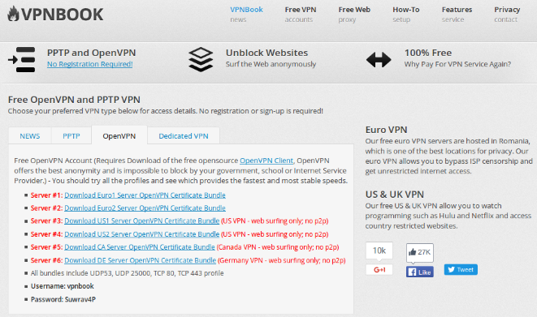The tutorial was very easy to follow and very short, taking about 10 minutes to setup.

First thing to do was download a certificate of an OpenVPN, a website “vpnbook” was linked in the tutorial, there we had to click on OpenVPN which gave a list of server certificates to download. We went with the first choice which was a European server. Once downloaded a file from the folder had to be chosen, any would do as the files were just different configuration settings. We used the file “vpnbook-euro1-tcp443.ovpn” and as followed created three empty documents named “ca.crt”, “cert.crt” and “key.key”. With these three empty, we then had to take code out of “vpnbook-euro1-tcp443.ovpn”

**Figure SEQ Figure \* ARABIC 1**

Between <ca> to </ca> we copy and pasted the code into ca.crt, the same was done between <cert> to </cert> and <key> to </key> and the code here was placed into cert.crt and key.key. The VPN software had to be installed before completing the network settings, this was done on the terminal and was very easy by just putting in one command it was installed.



The setup was all that was left to complete. On the top right the internet connection icon can be seen, click on this and go to VPN connections where there is the option to add a connection. Once it is added the details can then be edited, the three files mentioned earlier are placed into the User certificate, CA certificate and Private Key. Within the file “vpnbook-euro1-tcp443.ovpn” the IP Address for the VPN is taken and a username and password must be placed into the details, this info can be found on the vpnbook website, with the username being “vpnbook”. There was advanced setting to be complete based on the document we chose earlier, for ours we had to use custom gateway port 443 turn on both LZO data compression and TCP connection. In security we changed our Cipher to AES-128-CBC.

# *Results*

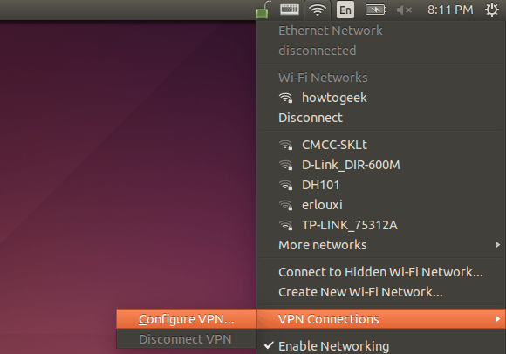The setup of the VPN was now complete and a connection could be attempted, unfortunately this connection was unsuccessful and gave us an error message.

Unsure of what our error was we retraced our steps and fixed some minor problems but still unsuccessful in our attempts to connect.

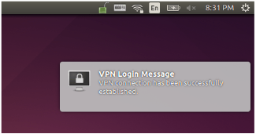Going back to the server certificates we decided to try a different server and downloaded US server #3, completing all the steps on this server we weren’t feeling optimistic with our many failed efforts but in the end this server gave us a successful connection to a VPN.

**Figure SEQ Figure \* ARABIC 3**

* 1. ***IP Location***

To verify we were actually using the VPN we checked our IP address, we used many websites to find our location but IP Location Finder seemed to be the best as it told us exact where we were when searching for our original IP address which was in C.I.T.

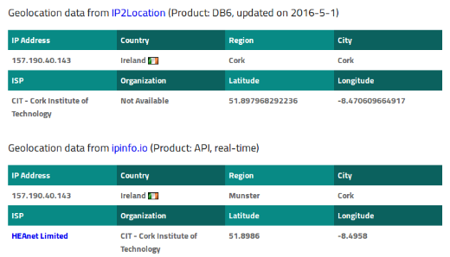We then turned on the VPN and refreshed the IP Location Finder page and our location change to Virginia U.S.A in Lease Web which we found out is an Internet hosting service.

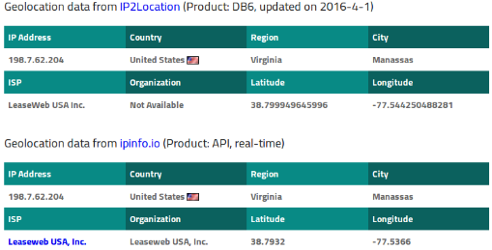

**Figure 4b**

A couple days later we tried to connect to the VPN but were unsuccessful, being very confused and annoyed by not being able to connect to our only working VPN we thought that it may be a one day VPN so we attempted to setup the network again but nothing changed. Going onto the vpnbook page an alteration was noticed. The password we used a couple days ago had changed. We tried the new password and connected to the VPN.

## *Speed Test*

We wanted to compare the speed of the college internet and VPN to see if this free and secure internet is actual good enough for permanent use. To find the speeds of both networks we used Ookla speed tester.

The results were extremely low in comparison to CIT internet. The VPN barely got over 1Mb download speed with its Upload speed weirdly being higher, the ping was outrageously high at 158ms, an average would be between 50ms – 10ms. Calculated the VPN download speed was about 0.3% what the college internet offered with the Upload speed being about 0.5%

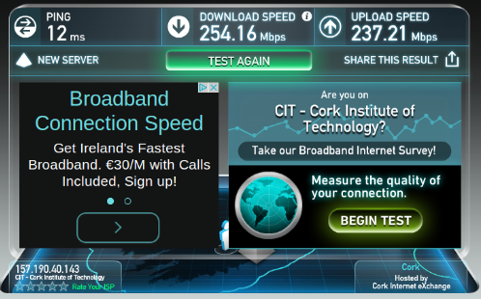

**Figure 5a**

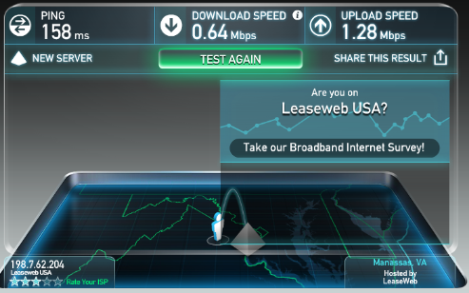

**Figure 5b**

# *Conclusion*

Through this Project we have learnt that a VPN is a safe way to surf the net without the fear of your data being jeopardized. Ubuntu was very easy to use and did not cause any problems being very similar to Windows. Through our success in setting up a VPN connection we are still unsure about why the European server didn’t work yet the US server did, also we never fixed our permission denied problem with numerous attempts on the first two VPN tutorials we tried.

We never checked how secure our VPN actual was but with the speed test results it wouldn’t be great for a household or business use, it seems the VPN we used would only be good for internet surfing and nothing more.

# References

<https://www.digitalocean.com/community/tutorials/how-to-set-up-an-openvpn-server-on-ubuntu-14-04> - first OpenVPN used

<https://github.com/Nyr/openvpn-install> - 2nd VPN used

http://ubuntuhandbook.org/index.php/2014/05/establish-openvpn-connection-ubuntu-1404/ - Final VPN

<https://www.youtube.com/watch?v=tcx2-EkYYDg> - YouTube Video

<https://www.iplocation.net/> - IP Location

<http://www.vpnbook.com/> - VPN certificate

<http://www.speedtest.net/> - Speed Test

# Appendices

|  |  |
| --- | --- |
| **Separation of Work** | |
| ***Adam*** | ***Dean*** |
| Configuring VPN | Research |
| Troubleshooting | Report Body |
| Presentation | Verifying VPN |
| Speed Test |  |